Context Switching in OS

MEDIUM Term Scheduler: Lately introduced.

* Sometimes degree of multiprogramming increases by LTS. So memory gets full in ready queue. So need to swipe out some processes.
* Swap out the excess processes in SWAP Space(Secondary space-ssd).
* Now if the processes from Ready queue are finished. So the processes from Swap space are swapped in.
* 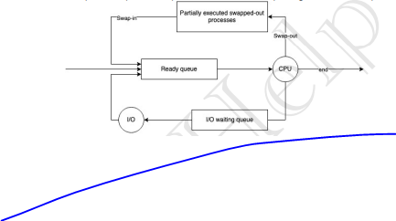
* This swap in and swap out is done by Medium Term Scheduler.

Context Switching:

* Restoring the previous context is context switching.